USE CASE DIAGRAM

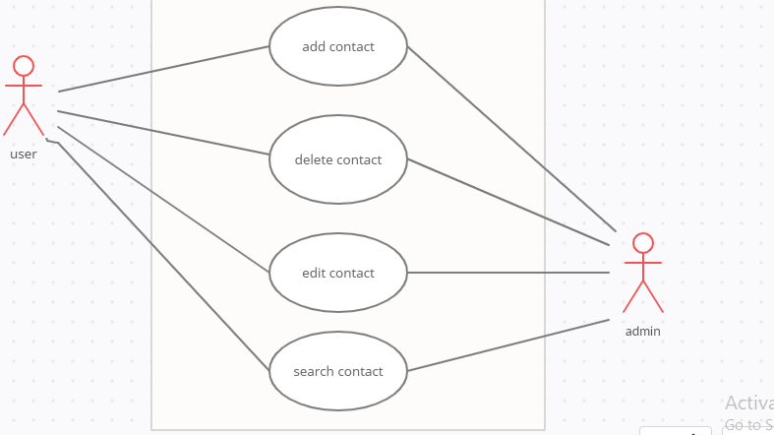

FLOW DIAGRAM

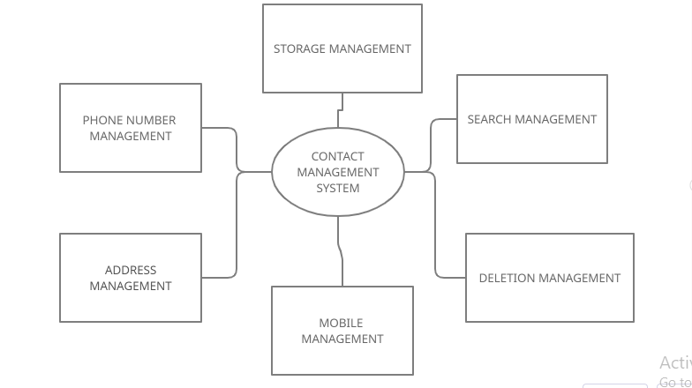

COMPONENT DIAGRAM

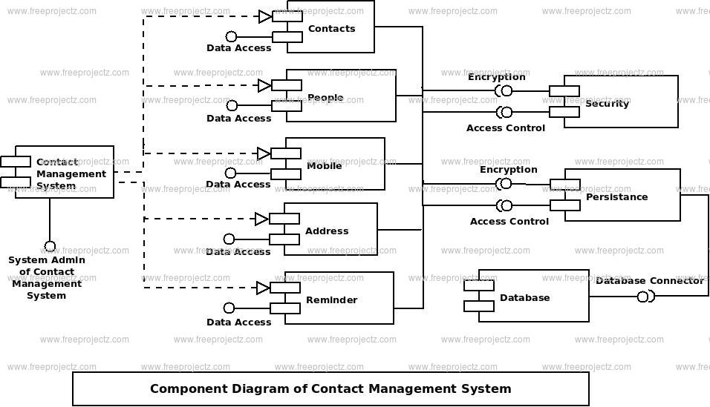

SEQUENCE DIAGRAM

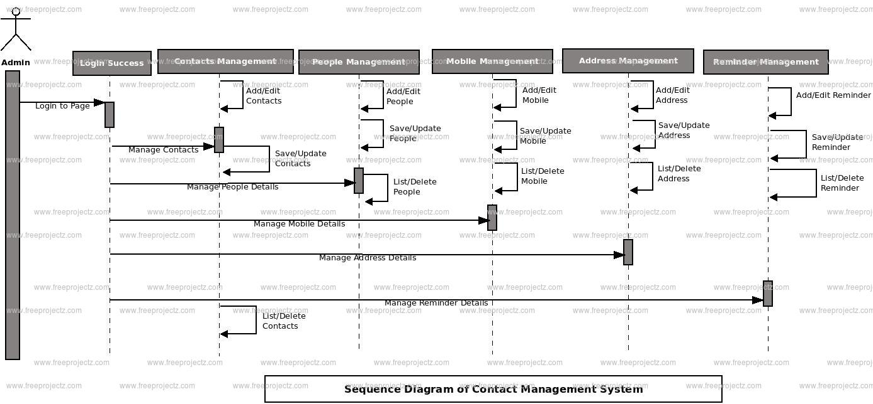

CLASS DIAGRAM

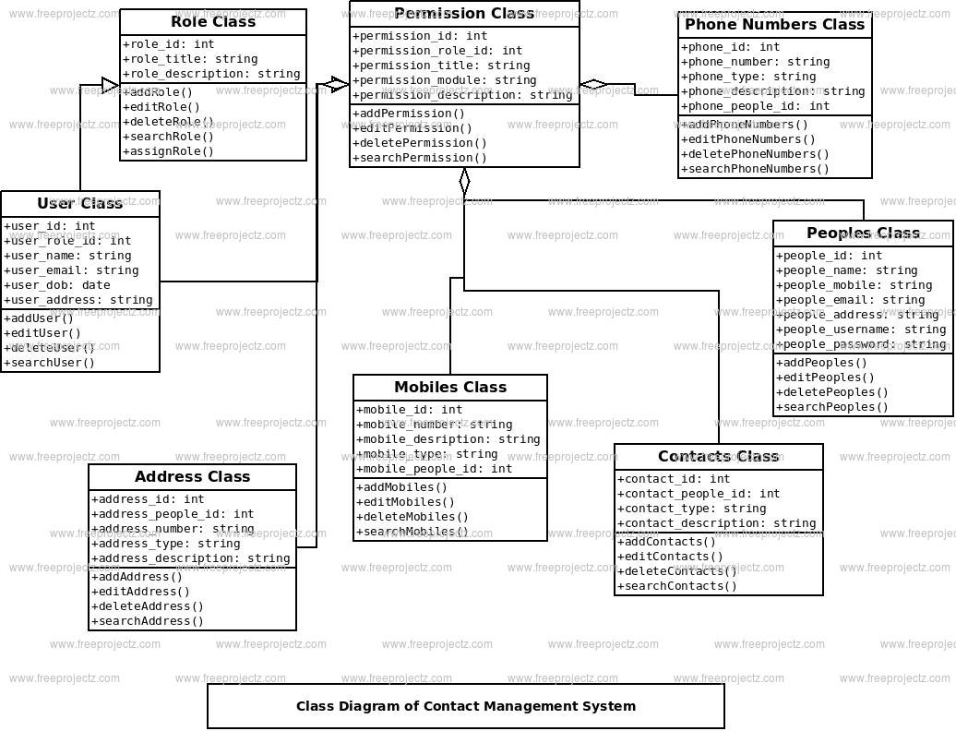

LOW LEVEL FUNCTIONALITIES OF CONTACT MANGEMEMNT SYTEM

